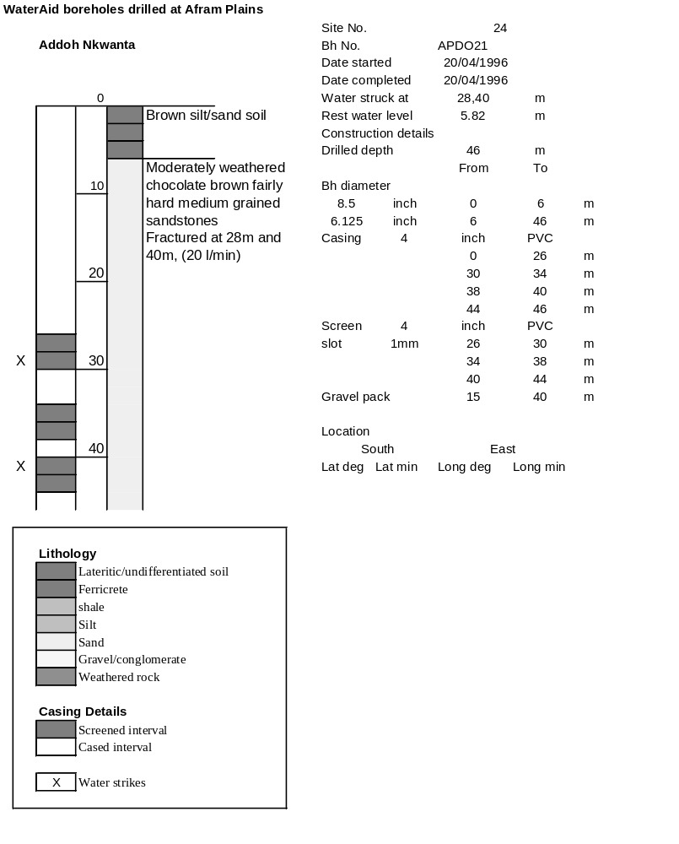

Ghana | Test pumping
Borehole No. |  | APDO21
Hole No |  | 24
Village |  | Addoh Nkwanta
Date |  | 28/04/1996
Point above GL |  | 0.5 | m
Pump depth |  | 33 | m
SWL |  | 6.32 | m
Start Time |  | 08:30
Drawdown test |  |  |  |  | Recovery test
time | pwl (m) | Q l/min | s (m) | sc | Time | wl (m) | s' (m) | t/t'
0.00 | 6.32 | 20.00 | 0.00 |  | 0.00 | 22.80 | 16.48
1.00 | 10.09 | 20.00 | 3.77 | 5.31 | 1.00 | 20.83 | 14.51 | 181.00
2.00 | 11.15 | 20.00 | 4.83 | 4.14 | 2.00 | 19.30 | 12.98 | 91.00
3.00 | 11.90 | 20.00 | 5.58 | 3.58 | 3.00 | 18.50 | 12.18 | 61.00
4.00 | 12.55 | 20.00 | 6.23 | 3.21 | 4.00 | 17.80 | 11.48 | 46.00
5.00 | 12.83 | 20.00 | 6.51 | 3.07 | 5.00 | 17.10 | 10.78 | 37.00
6.00 | 13.10 | 20.00 | 6.78 | 2.95 | 6.00 | 16.50 | 10.18 | 31.00
7.00 | 13.38 | 20.00 | 7.06 | 2.83 | 7.00 | 15.80 | 9.48 | 26.71
8.00 | 13.54 | 20.00 | 7.22 | 2.77 | 8.00 | 15.10 | 8.78 | 23.50
9.00 | 13.71 | 20.00 | 7.39 | 2.71 | 9.00 | 14.81 | 8.49 | 21.00
10.00 | 13.85 | 20.00 | 7.53 | 2.66 | 10.00 | 14.42 | 8.10 | 19.00
11.00 | 13.98 | 20.00 | 7.66 | 2.61 | 12.00 | 13.80 | 7.48 | 16.00
12.00 | 14.08 | 20.00 | 7.76 | 2.58 | 14.00 | 13.10 | 6.78 | 13.86
13.00 | 14.27 | 20.00 | 7.95 | 2.52 | 16.00 | 12.56 | 6.24 | 12.25
14.00 | 14.24 | 20.00 | 7.92 | 2.53 | 18.00 | 11.88 | 5.56 | 11.00
15.00 | 14.34 | 20.00 | 8.02 | 2.49 | 20.00 | 11.18 | 4.86 | 10.00
16.00 | 14.38 | 20.00 | 8.06 | 2.48 | 22.00 | 10.53 | 4.21 | 9.18
17.00 | 14.49 | 20.00 | 8.17 | 2.45 | 24.00 | 9.95 | 3.63 | 8.50
18.00 | 14.61 | 20.00 | 8.29 | 2.41 | 26.00 | 9.43 | 3.11 | 7.92
19.00 | 14.76 | 20.00 | 8.44 | 2.37 | 28.00 | 9.10 | 2.78 | 7.43
20.00 | 14.91 | 20.00 | 8.59 | 2.33 | 30.00 | 8.80 | 2.48 | 7.00
22.00 | 15.18 | 20.00 | 8.86 | 2.26 | 35.00 | 8.33 | 2.01 | 6.14
24.00 | 15.50 | 20.00 | 9.18 | 2.18 | 40.00 | 8.07 | 1.75 | 5.50
26.00 | 15.77 | 20.00 | 9.45 | 2.12 | 45.00 | 7.85 | 1.53 | 5.00
28.00 | 16.07 | 20.00 | 9.75 | 2.05 | 50.00 | 7.72 | 1.40 | 4.60
30.00 | 16.36 | 20.00 | 10.04 | 1.99 | 60.00 | 7.52 | 1.20 | 4.00
35.00 | 16.96 | 20.00 | 10.64 | 1.88 | 70.00 | 7.45 | 1.13 | 3.57
40.00 | 17.45 | 20.00 | 11.13 | 1.80 | 80.00 | 7.36 | 1.04 | 3.25
45.00 | 17.93 | 20.00 | 11.61 | 1.72 | 90.00 | 7.28 | 0.96 | 3.00
50.00 | 18.33 | 20.00 | 12.01 | 1.67 | 100.00 | 7.22 | 0.90 | 2.80
55.00 | 18.68 | 20.00 | 12.36 | 1.62 | 110.00 | 7.18 | 0.86 | 2.64
60.00 | 19.03 | 20.00 | 12.71 | 1.57 | 120.00 | 7.13 | 0.81 | 2.50
70.00 | 19.61 | 20.00 | 13.29 | 1.50
80.00 | 20.31 | 20.00 | 13.99 | 1.43
90.00 | 20.95 | 20.00 | 14.63 | 1.37
100.00 | 21.36 | 20.00 | 15.04 | 1.33
110.00 | 21.67 | 20.00 | 15.35 | 1.30
120.00 | 21.94 | 20.00 | 15.62 | 1.28
130.00 | 22.17 | 20.00 | 15.85 | 1.26
140.00 | 22.34 | 20.00 | 16.02 | 1.25
160.00 | 22.58 | 20.00 | 16.26 | 1.23
180.00 | 22.80 | 20.00 | 16.48 | 1.21
